19.38: a)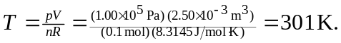

b) i) Isothermal: If the expansion is isothermal, the process occurs at constant temperature and the final temperature is the same as the initial temperature, namely 

ii) Isobaric:
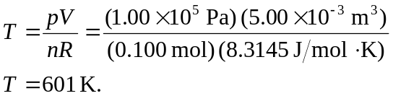
iii) Adiabatic: Using Equation (19.22), 